A guide of the interactive demonstration for ***Who-When-Where*** co-patterns discovered by PS-HDP model on StudentLife dataset

The product-space hierarchical Dirichlet process (PS-HDP) model is designed to discover co-patterns from heterogeneous data. We apply the PS-HDP model on the StudentLife dataset to discover Who-Where-When (a.k.a Proximity-Location-Time) co-patterns as described in [1]. 17 patterns has been discovered and visualized as a network using Gephi [2]. Furthermore, we use the JavaScript GEXF Viewer for Gephi [3] to let people interact and explore those Who-Where-When patterns.

The network of Who-When-Where co-patterns from StudentLife dataset are shown below.

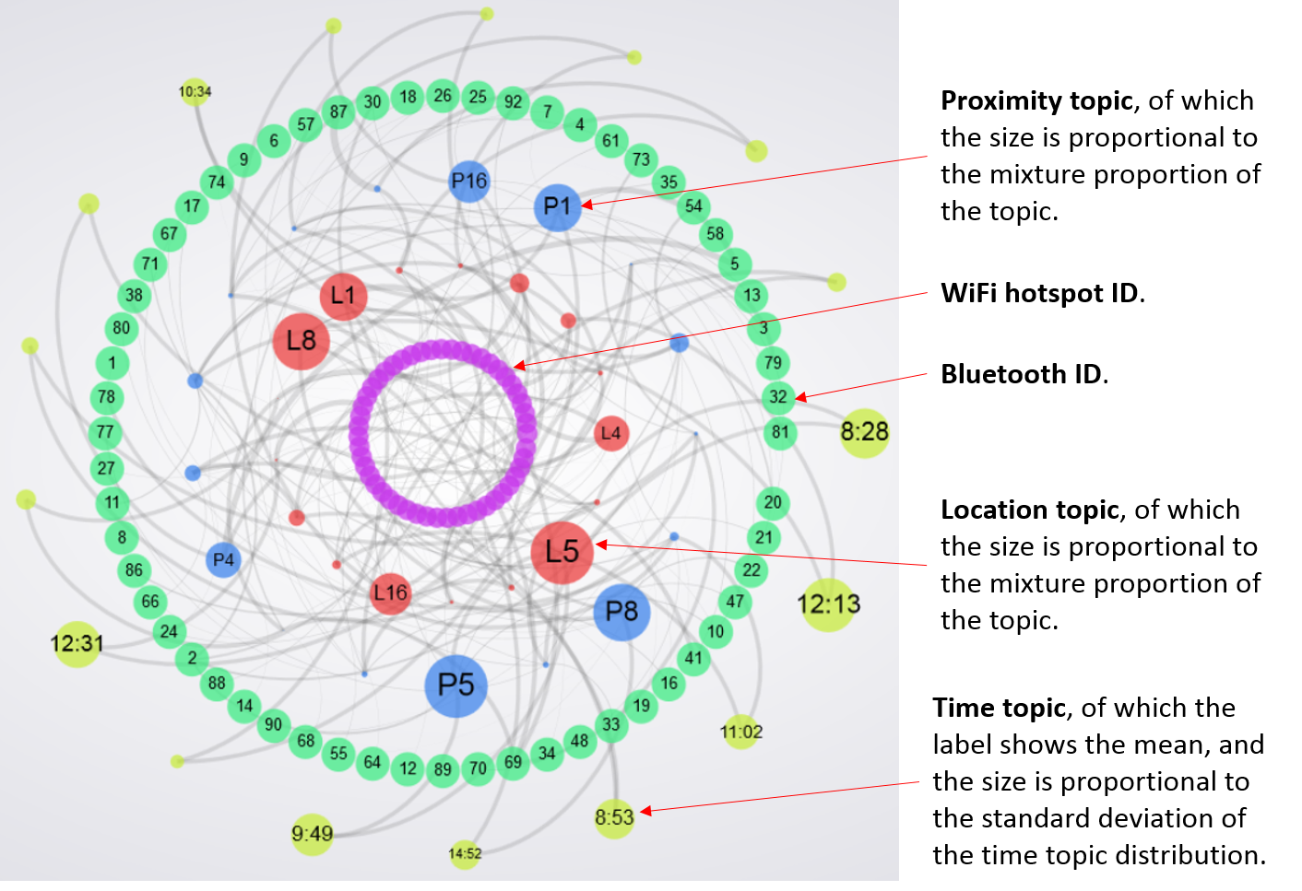

When a user clicks on a proximity topic (prefixed by P), its corresponding Bluetooth IDs and location/time topics are highlighted. In the figure below, one can see that the proximity topic P4 includes Bluetooth IDs 7, 5, 10, 64 and 14; among them, the Bluetooth ID 5 is present the most. P4 has also been connect to the time topic 19:48, which has a small size, implied that this group of people (7, 5, 10, 64 and 14) usually meet each other around 19:48 with a high confidence.

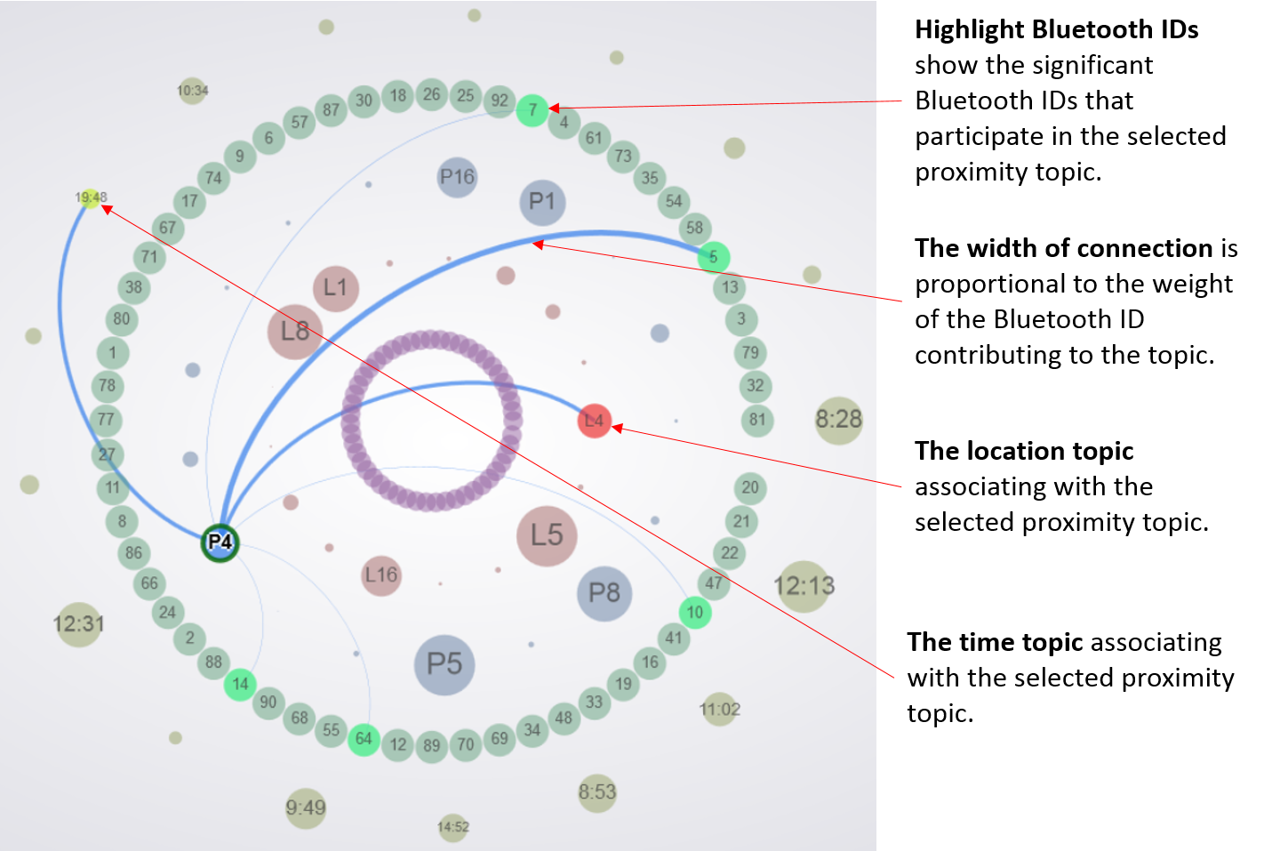

The proximity topic P4 is associating with the location topic L4. To explore L4, a user can click on it and significant WiFi IDs of the topic L4 will be highlighted. In the figure below, one can see that L4 is a location that close to WiFi hotspot ID 1, 2, 10, 13 and 14, and the WiFi ID 2 is the most contributing to topic L4.

